

EBAY CONTROLLER TEST DATA SHEET

P/N: 414-8005-95 Date: 16/04/2018

S/N: 0 Time: 09:32

UA: 95 Tested by: csd

Hardware Rev: BLDC_60A_V6 Approved by: csd

Software Rev: 5.3.9

Tester Software Version: 1.2l

Equipments Used

Equipments Model No Serial No

Power Supply

Digital Multimeter

CAN Interface

BLDC Tester

PC

Heater

RS-232 Interface

Current Meter

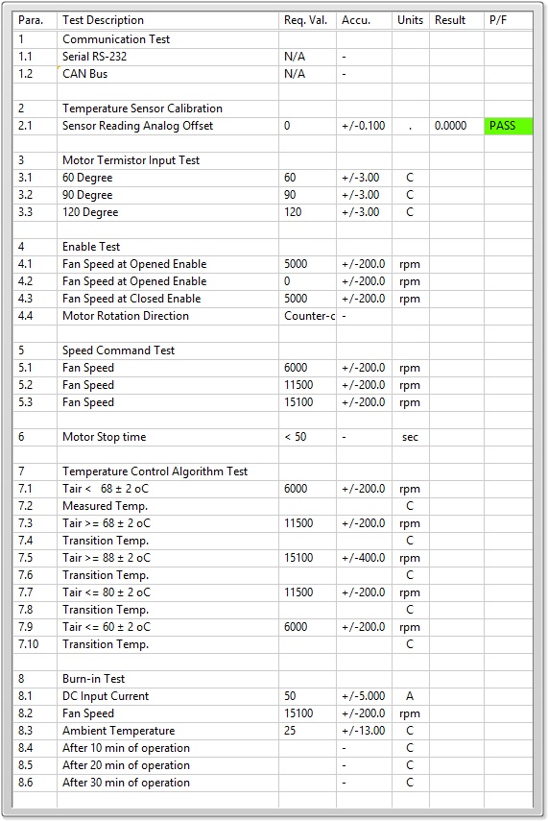

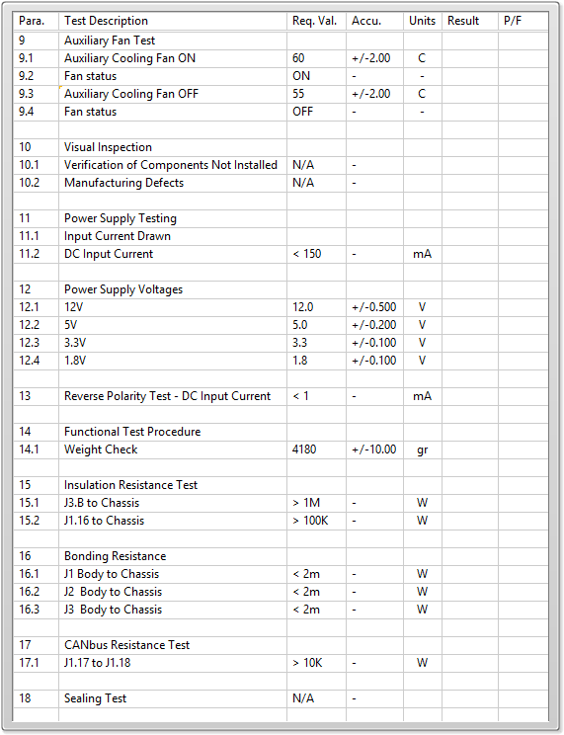

General result:

Test-Operator:____ csd_________ Q.A.:__________________________